Solar System PhET
Procedure:
1. Solar System PhET LINK
2. Once you are on the site, click the “Show Grid” box on the right of the screen.
3. Drag the slider from “Fast” all the way over to “Accurate”.
4. At the bottom, select “3” for the number of bodies. Then fill out the data table to look like this:
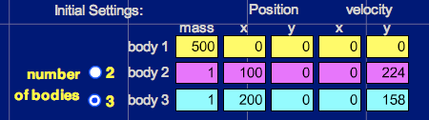
5. Click on “Start” and observe the motion, then answer the questions in complete sentences in your Notebook.
Q1: Which planet (inner or outer) travels the least distance to go around once?

Q2: Which planet is going the fastest?

Q3: Which planet has the shortest “year”?

Q4: About how many times does the inner planet go around while the outer planet goes around once?

Q5: In our solar system, what is the name of the planet that goes the fastest? The slowest?

6. Click “Stop”, then click on the arrow next to “Select Preset” in the upper right of the screen.
7. Scroll down and select “Ellipses”.
8. Click “Start” and answer the following questions about the outer GREEN orbit relative to the yellow “Sun”.
Q6: Where in its orbit is the planet going the fastest? Slowest?

Q7: Where do you think gravity is the strongest? Weakest?

Q8: Comets have orbits similar to this one. Where would you expect a comet to spend most of its time, near the Sun or far from the Sun? Why?

10. Run the simulation until the purple planet (body 2) has made one complete orbit (one year).
11. After the first orbit (year), turn off the traces (show traces box) and watch another orbit (year) of the purple planet (body 2). Answer the following question.
Q9: Is the blue moon (body 3) circling the yellow sun (body 1) or the purple planet (body 2)? Explain your answer.

12. Increase the mass of the sun (body 1) to 400 and allow the simulation to run for one complete orbit of the purple planet (body 2).
13. Decrease the mass of the sun (body 1) to 175 and allow the simulation to run for one complete orbit of the purple planet (body 2). (~90 seconds). Answer the following question.
Q10: How do the orbits of the planets change when the mass of the sun is increased or decreased? Why? Explain your answer.

