Name:________________________
Date:_____________ Per:________
Metric System Worksheet (#1)
1. What number is the metric system based on?

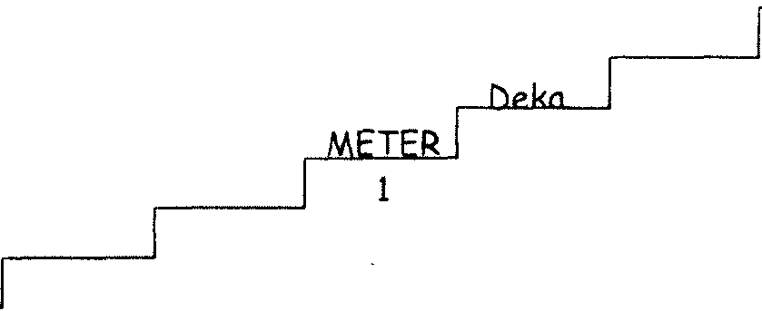
2. Complete the following "metric staircase".

.001
or 1/100

3. Make the following conversions:

- 1 m = __________ cm e. 1 m = __________ mm i. 1 m = __________ dm
- 1 m = __________ hm f. 1 m = __________ km j. 1 m = __________ dam
- 32 cm = _______ mm g. 95 km = ________ m k. 593 hm = _______ dm
- 0.23 dam = ______cm h. 49 mm = ________ m l. 57 km = ________ m
4. What is another name for the metric system?

5. What is the "base unit" for each of the following in the metric system?

a. length = __________ b. mass = _____________

c. temperature = ________ d. volume = ______________

